Delaware Valley Chess Club
Lesson 8
Boden’s Mate
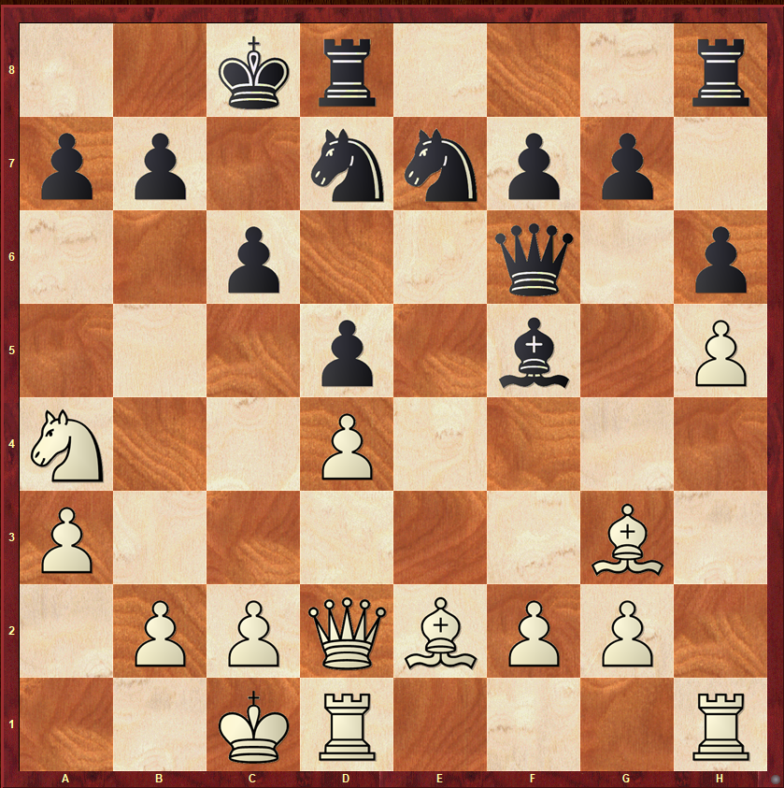
Black to Move
Very similar to both Balestra’s and the two Bishop Mate, Boden’s mate shows up in practice quite a bit and is easy to miss if you are not aware of this pattern.

Square Clearance
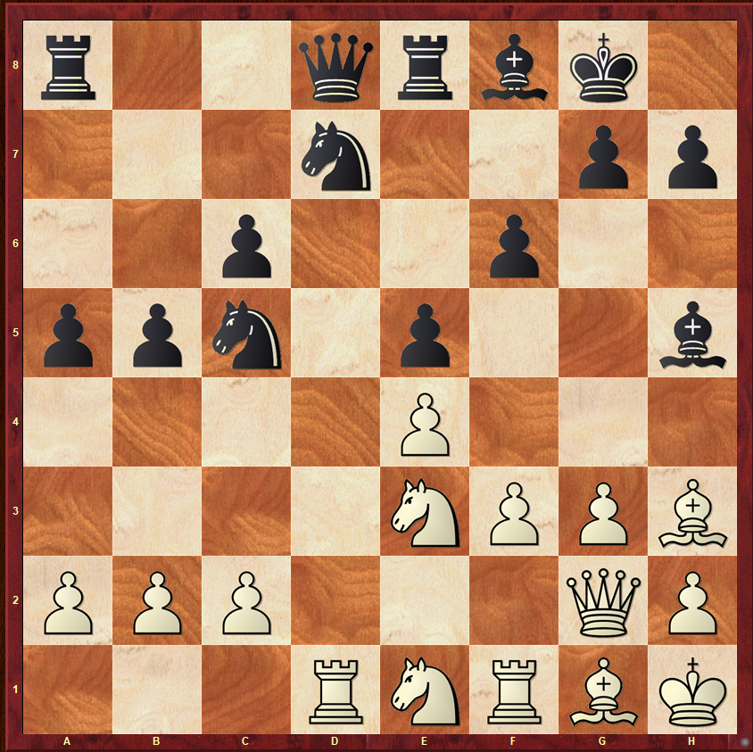
Black to Move
A player moves one of his own pieces to clear a square so that another one of their pieces can use the square.

Basic Mate – 2 Bishops
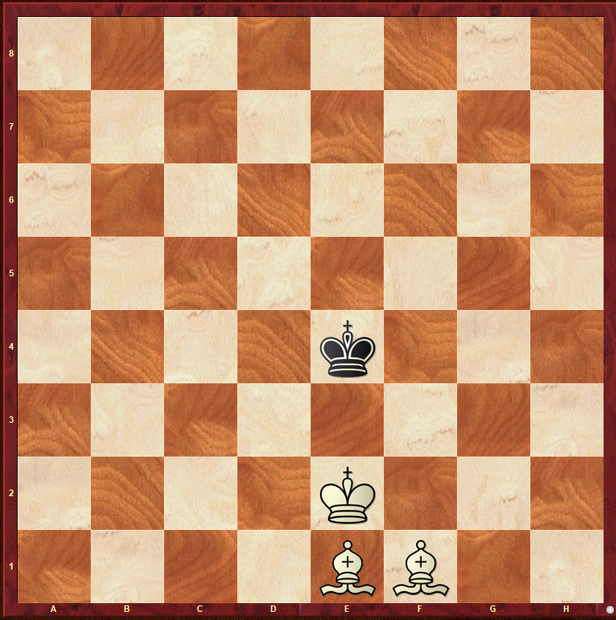
White to Move
This is the last of the basic mates we are going to cover for a while. Mate with a Knight and Bishop will be covered after we work on some pawn endings. This mate is similar to Rook mates. We create a cage, drive the King to the edge, and Mate.

Delaware Valley Chess Club
Lesson 8
NAMES OF OPENINGS

I thought that we could take 1 small set of opening moves each week and learn the names of the most popular openings.
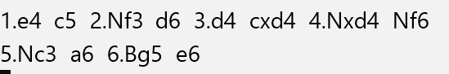See the Diagram – After Black played c5 he said I think I’ll play the Sicilian. Once upon a time the automatic and most played response to 1.e4 was 1…e5. Now 1…c5 the Sicilian is the most popular opening. The Sicilian has many variations. We will look at a few variations as we move through the material. After Black plays e6 he enters the Scheveningen Variation
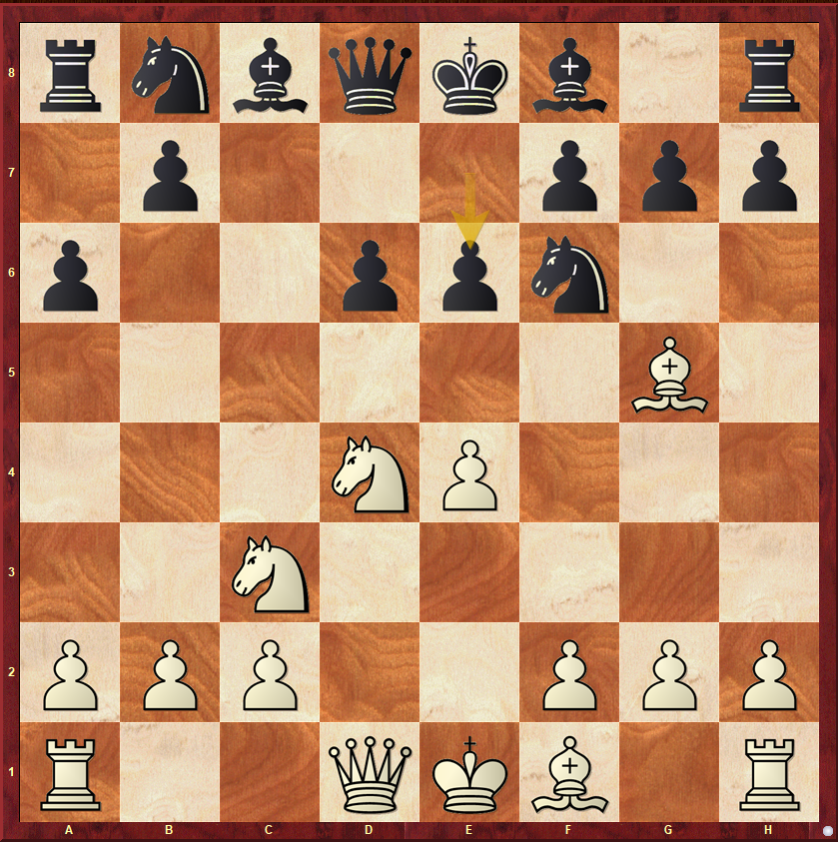

Delaware Valley Chess Club
Lesson 8
NAMES OF OPENINGS
Let’s look at the Pawn Structure of the Scheveningen Variation.
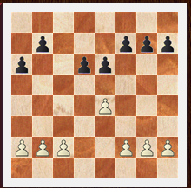
What should White do with this kind of structure?

Delaware Valley Chess Club
Lesson 8
NAMES OF OPENINGS
White's plans
1. Launch a kingside attack with g2-g4-g5, h2-h4-h5 and then break with g5-g6.
2. Play f2-f4-f5 to pressure the e6-pawn and create an attack along the a2-g8 diagonal.
3. Play f2-f4 and then e4-e5 and then later carry out a kingside attack.
Let’s figure out what Black should do on the next page.
Delaware Valley Chess Club
Lesson 8
NAMES OF OPENINGS

Black's plans
1. Achieve the central break ...d6-d5 to release the position and activate his minor pieces.

2. Play along the c-file and place a knight on c4to pressure the b2-pawn and undermine White's knight which is typically located on c3.
3. If White has castled long, then carry out a queenside attack with ...b7-b5-b4, ...a7-a5-a4, and then the break ...b4-b3.
4. If White plays f2-f4, in some cases Black can reply ...g7-g5 to fight for the control of the e5-square.

5. In some cases, Black may sacrifice an exchange on c3.

Black will most likely castle short or on some occasions keep the king in the center. Meanwhile, White's king must choose between long and short castling, which will greatly influence the development of the
Delaware Valley Chess Club
Lesson 8
NAMES OF OPENINGS
game. If White castles long, then his main lines plans will be 1 and 2 while Black will most probably focus on Plan 3. Instead, if White castles short, Black will focus on Plan 1 while White can still carry out a kingside attack. White's Plan 3 is more likely to work after short castling because the rooks would be placed more favorably for this plan.

One of the fascinating things about this structure is that it can transform into other structures. If you understand pawn structures than you can adapt your plans – A lecture for a much later date.
Delaware Valley Chess Club
Lesson 8

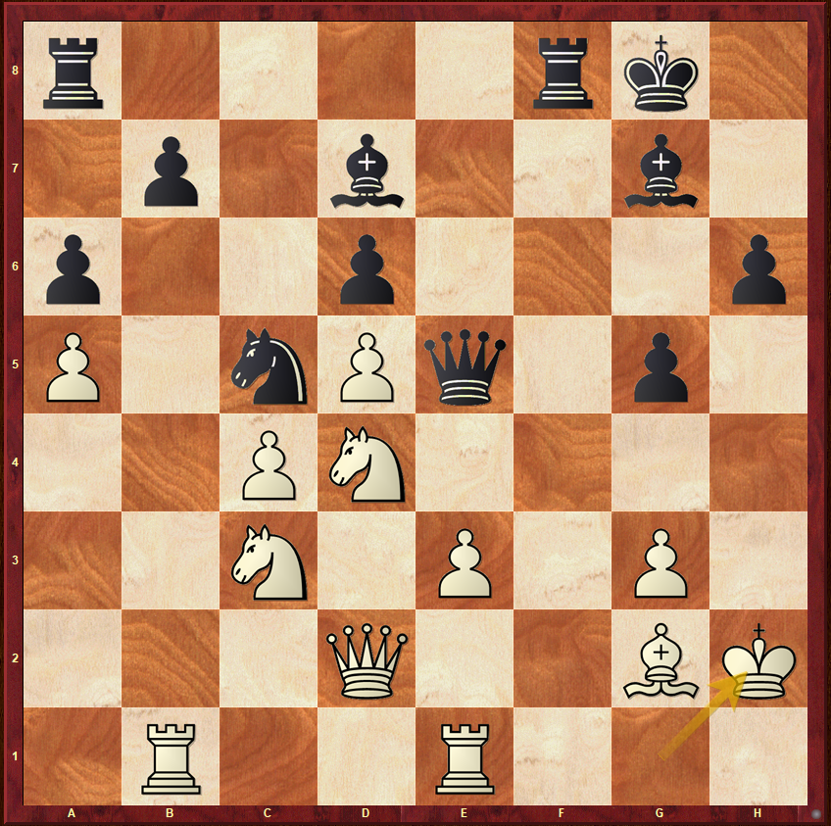

How can Black turn his active Position into a winning one?

