Delaware Valley Chess Club
Lesson 7
Attacking (1)
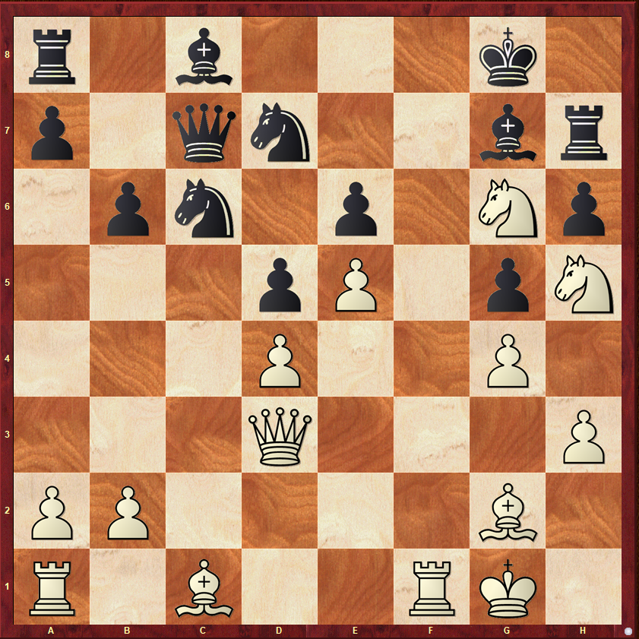
White to Move
I have been neglecting the more experienced players over the last few weeks, so this week I am hoping to make amends. Please tell a story about the above position.

Attacking (2)
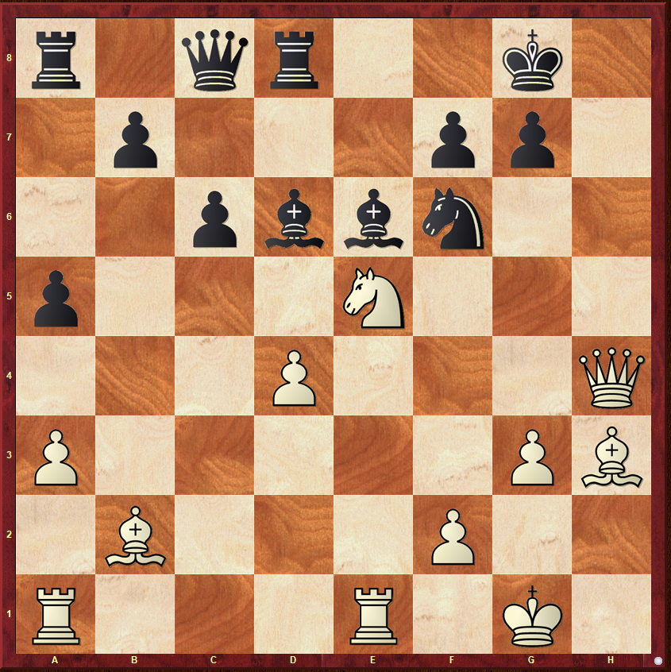
White to Move
This is an analysis position from a Taimanov game. We need another story.

A Pawn Endgame
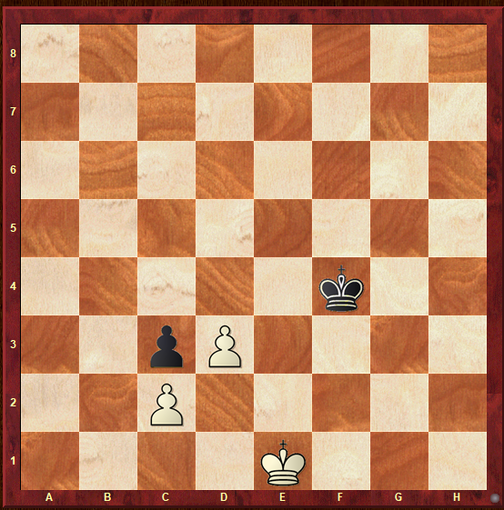
Black to Move
This position is one of correspondence not opposition. With that hint – What should be the outcome?

Delaware Valley Chess Club
Lesson 7
A Pawn Endgame (2)
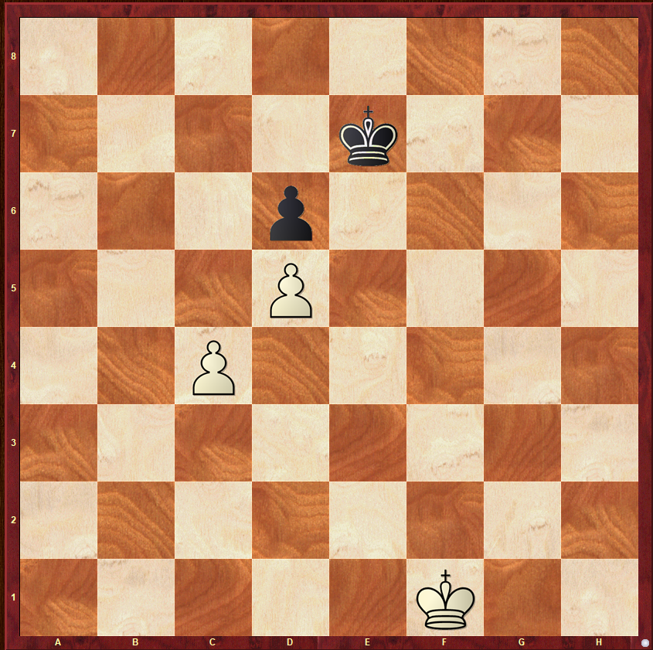
White to Move
Opposition vs Correspondence

