Delaware Valley Chess Club
Lesson 6
Arabian Mate (1)
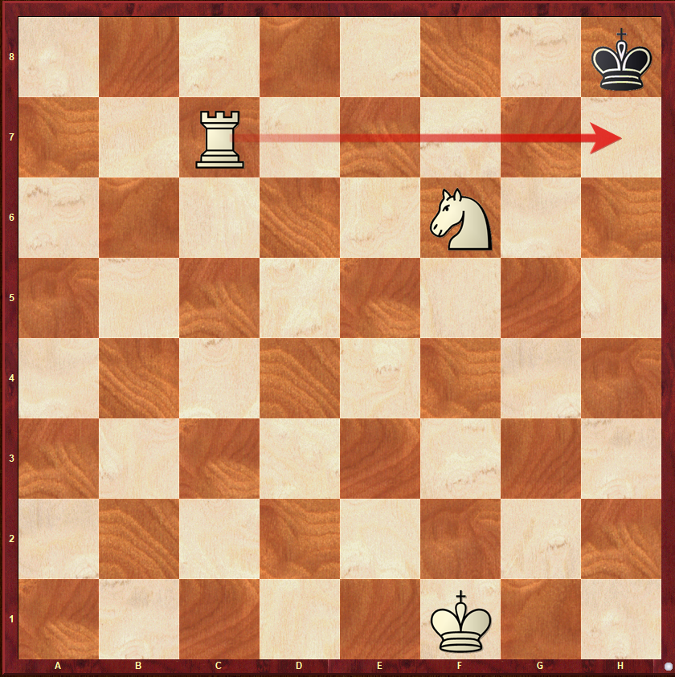
White to Move
When Rooks become active in the middlegame they like to penetrate to the 7th & 8th rank. When they act in concert with a Knight on f6 they become very dangerous. This is the oldest of mates.
Zwischenzug (1)
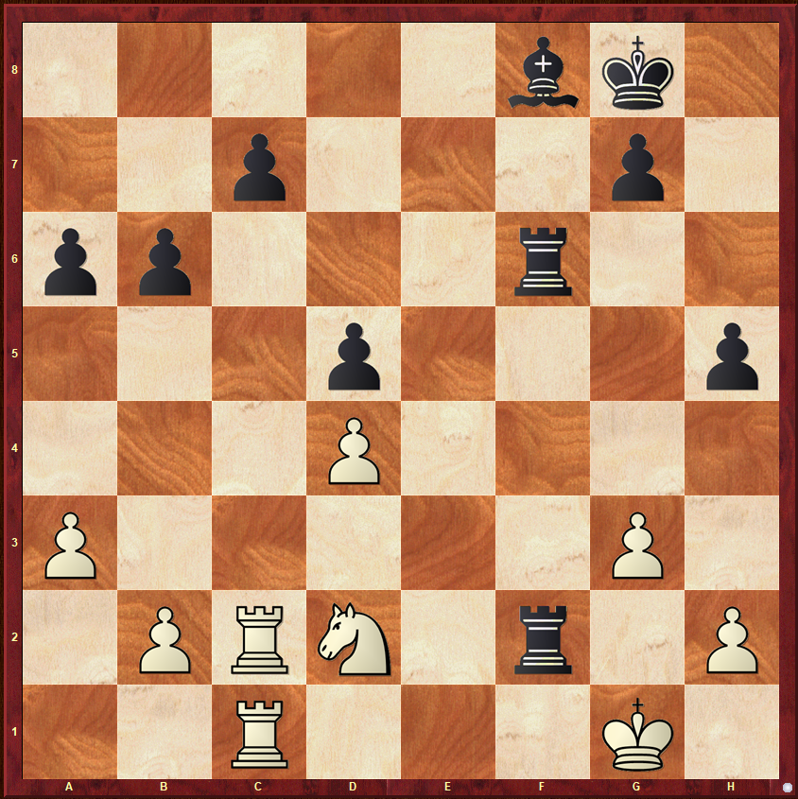
White to Move
Today’s lesson is about Zwischenzug/intermezzo/in-between move. Sometimes we don’t do the expected move instead we do an in-between move or Zwisenzug.
King & Rook vs King
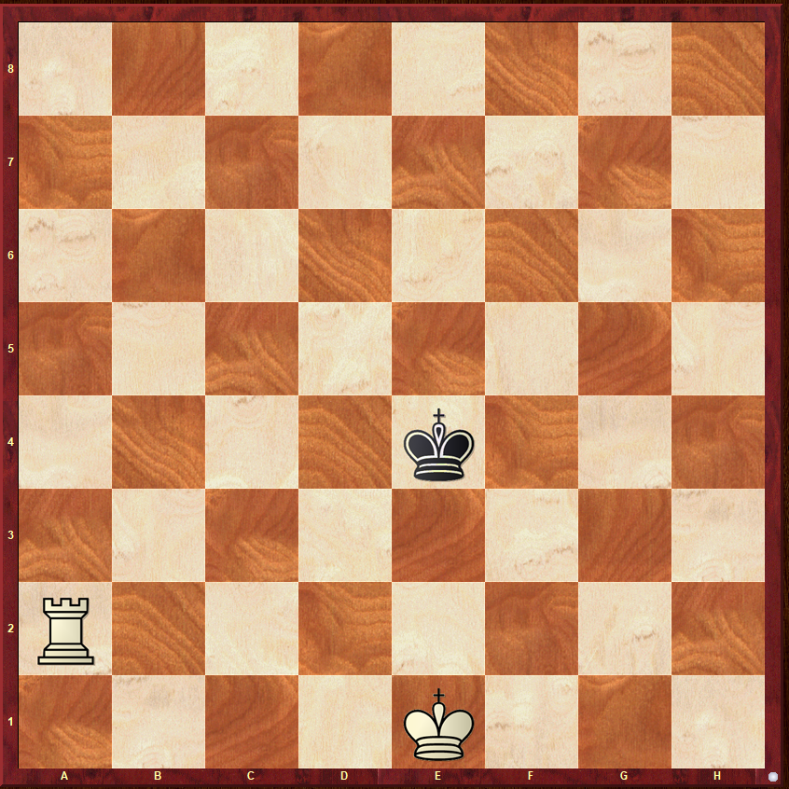
White to Move
Last week we talked about a very safe method of driving the King back using opposition and checks. This week we will evaluate the 2nd method – Rook shrinks the board & King protects the Rook.

Delaware Valley Chess Club
Lesson 6

Sicilian Najdorf
Let’s Take our 1st look at an opening called the Najdorf Sicilian. It starts with the moves:

1.e4 c5 2.Nf3 d6 3.d4 cxd4 4.Nxd4
Nf6 5.Nc3 a6 – See Diagram. 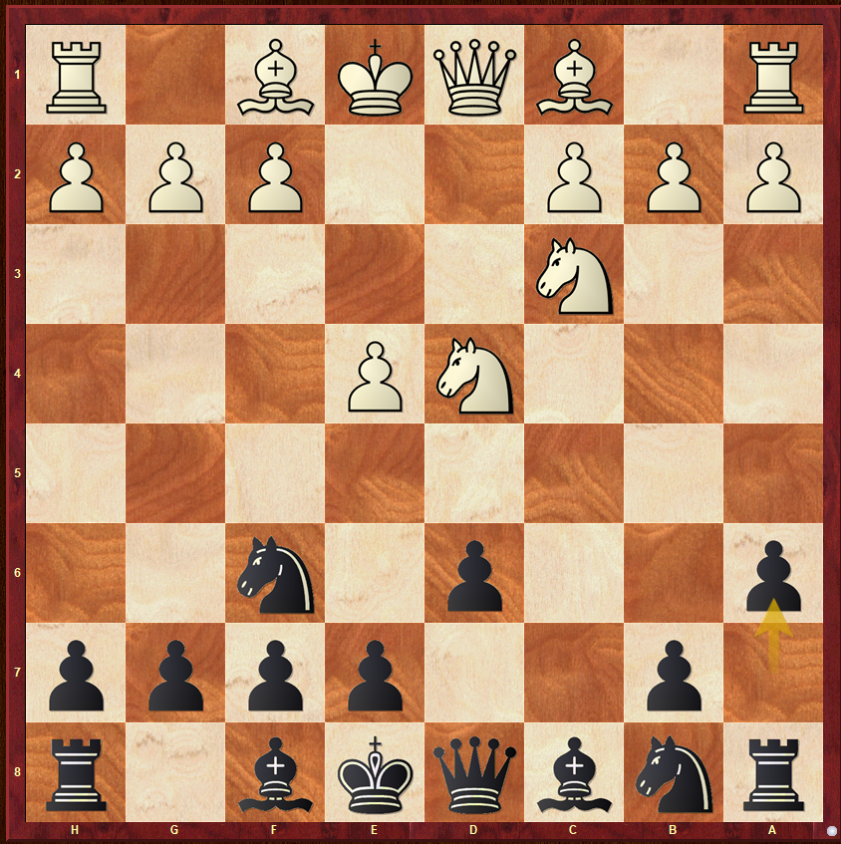
Today we are going to play a “thematic game”. The diagramed position will be the starting position. From here the game can take on many variations. We will evaluate some of them. Some lines are very important in chess history like the Polugaevsky and the Poisoned Pawn variations

Delaware Valley Chess Club
Lesson 6

Arabian Mate (2)
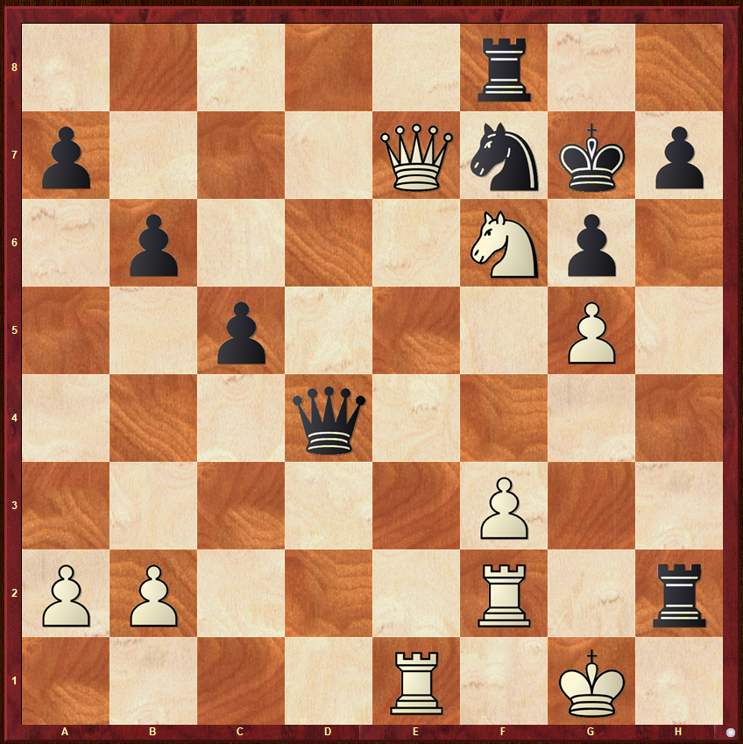
White to Move

Zwischenzug (1)
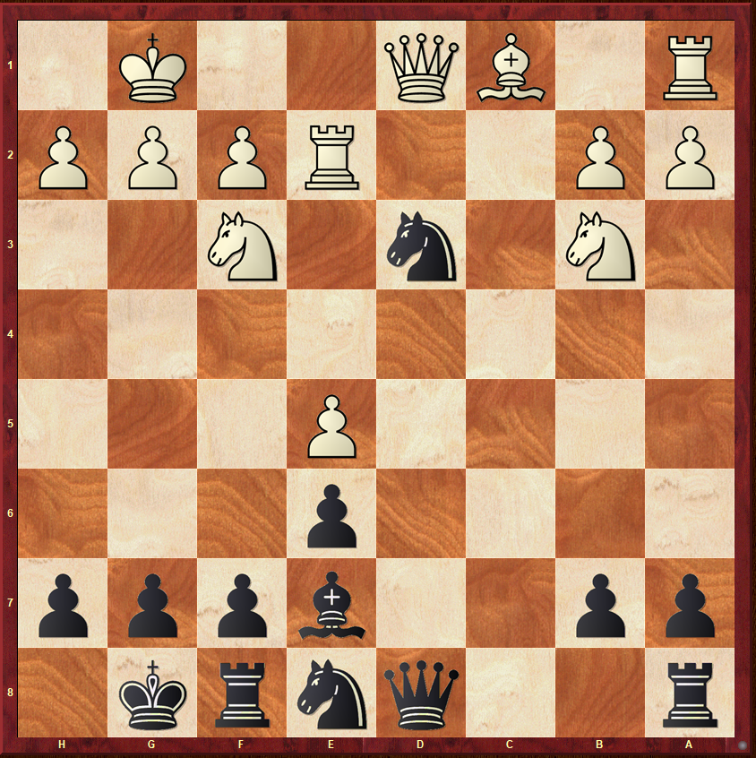
Black to Move

Philidor 1 –
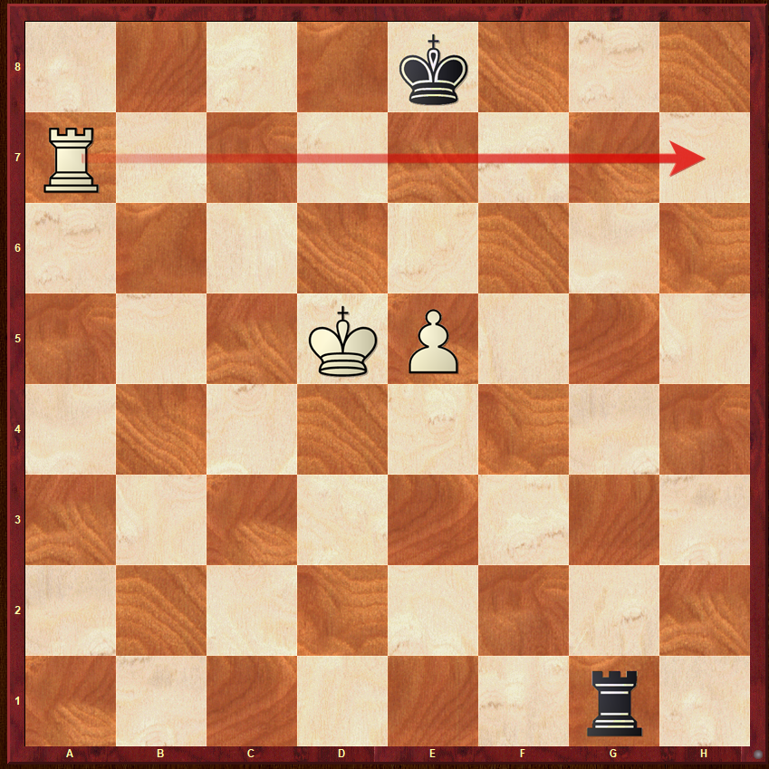
One More Time
Black to Move

