Delaware Valley Chess Club
Lesson 5
Back Rank Mate
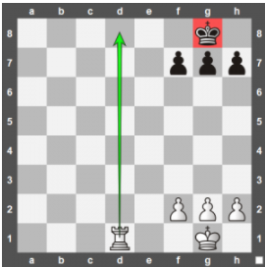
White to Move
I was going to talk about the Arabian Mate but decided to jump to the Back Rank Mate.
The Back Rank Mate happens when a king is trapped behind its own pawn shield and gets mated by a rook or queen:
Battery
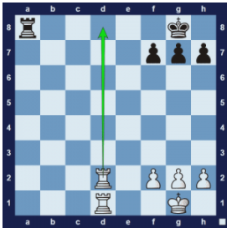
White to Move
In chess, a battery refers to lining up two or more pieces on the same diagonal, rank or file. Only queens, rooks, and bishops can form a battery. The Rooks or Queen and Rooks form a battery on ranks or files. The Queen and Bishop can form a battery on the diagonals.
Basic Mates
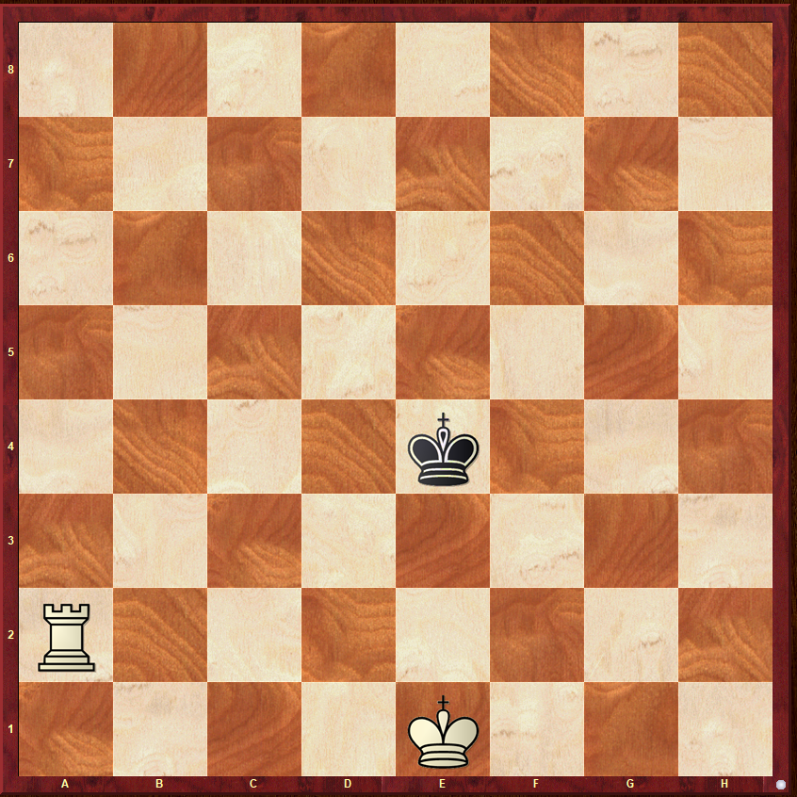
White to Move
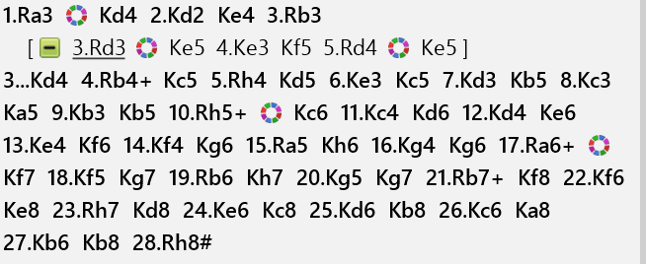

Delaware Valley Chess Club
Lesson 5
CENTRAL CONTROL
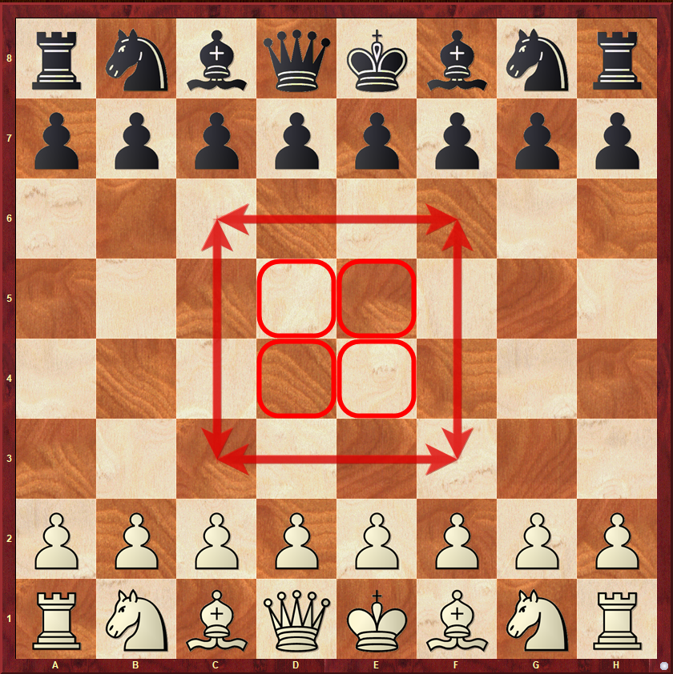
The most important squares are the 4 central squares. In the opening, this should be your main focus. You should try to get your pieces in or near the center since from there your pieces have the most power. The squares inside the box are called the extended center.

If you have more pawns in the center than your opponent, then you have a central majority. This is very important in many openings. Having a central majority is considered an advantage.
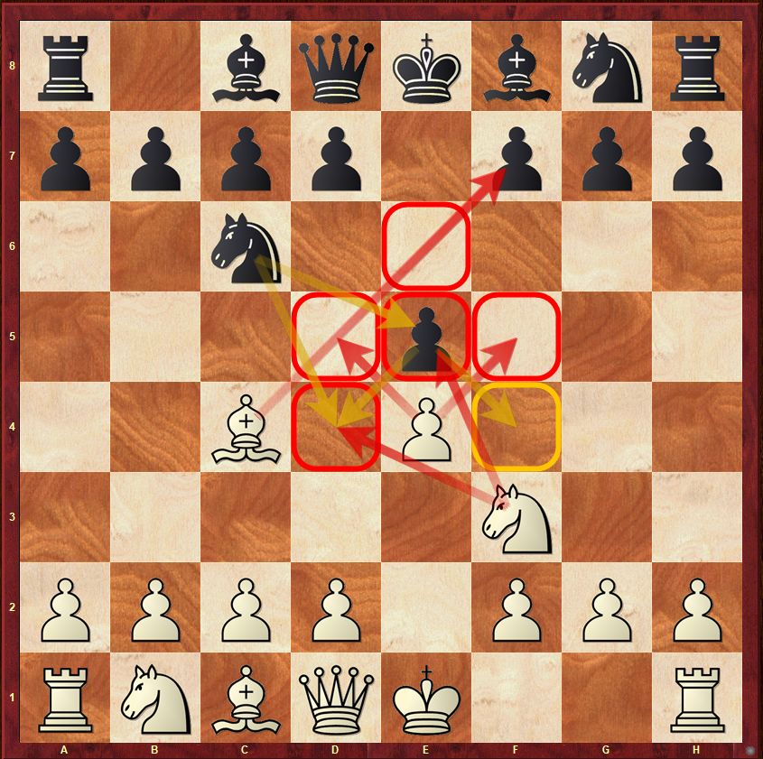
After the following moves you can see that both players are striving to control the center.
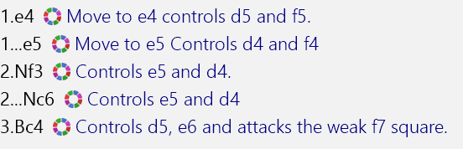

Delaware Valley Chess Club
Lesson 5

A Philidor Position

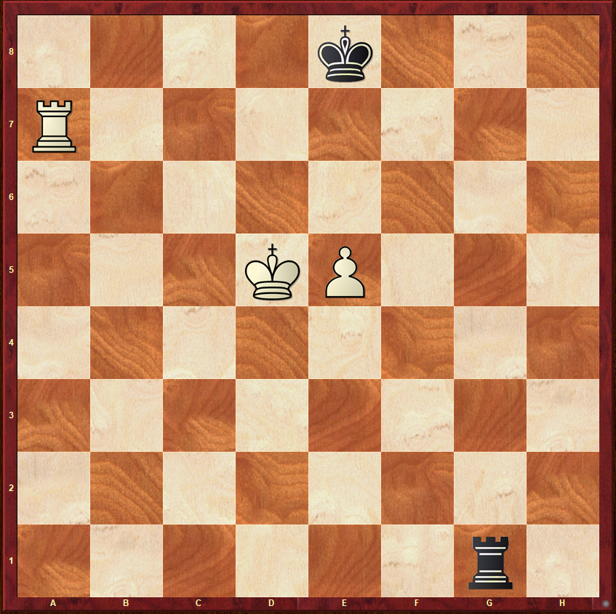
Black to Move
In this position, it is Black to Move. White has an extra pawn and if he can get his Pawn to the 8th Rank the Pawn will promote to a Queen. With a Queen and a Rook White will win. Black’s job is to prevent the Pawn from becoming a Queen and draw the game.

Your homework is to review the lesson on this position and make sure you are able to draw – Come back and teach me how to draw. Teach me this position and 2 others and you win the award shown on the right.

