Delaware Valley Chess Club
Lesson 3
Anastasia’s Mate
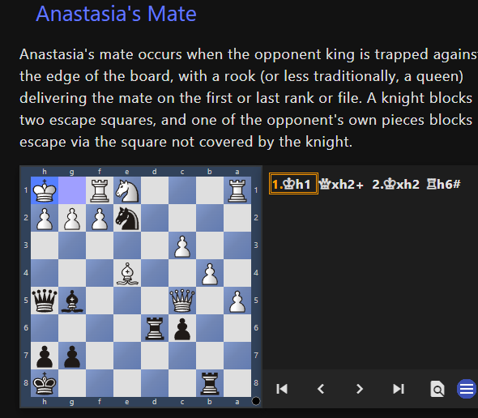

Discovered Attack
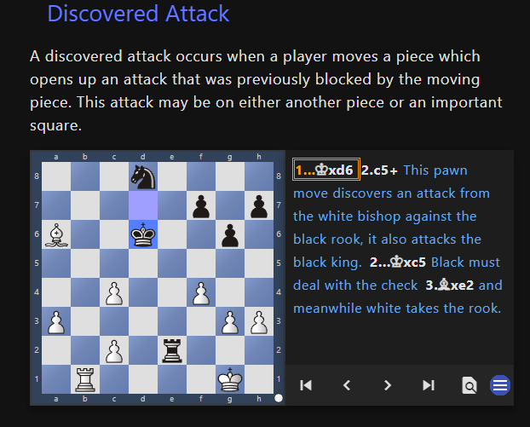

Basic Mates
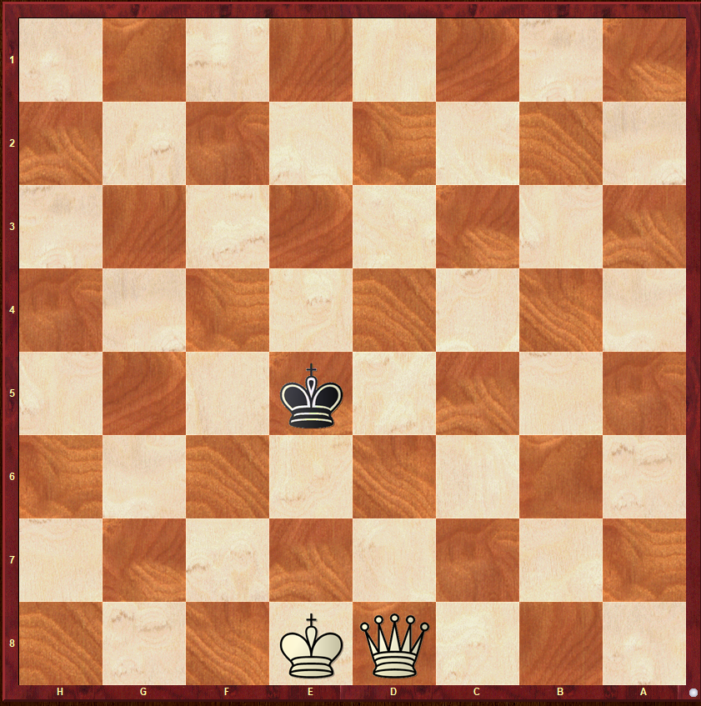
White to Move
This is the simplest of the Basic mates –
King and Queen vs. King. There are many ways White can give mate. Below is just one of the ways.

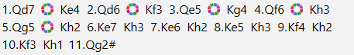

Delaware Valley Chess Club
Lesson 3

A TABIA – QUEEN’S GAMBIT ACCEPTED

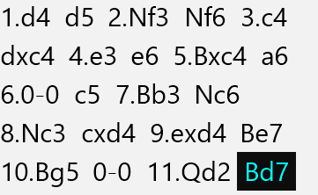
Tabia
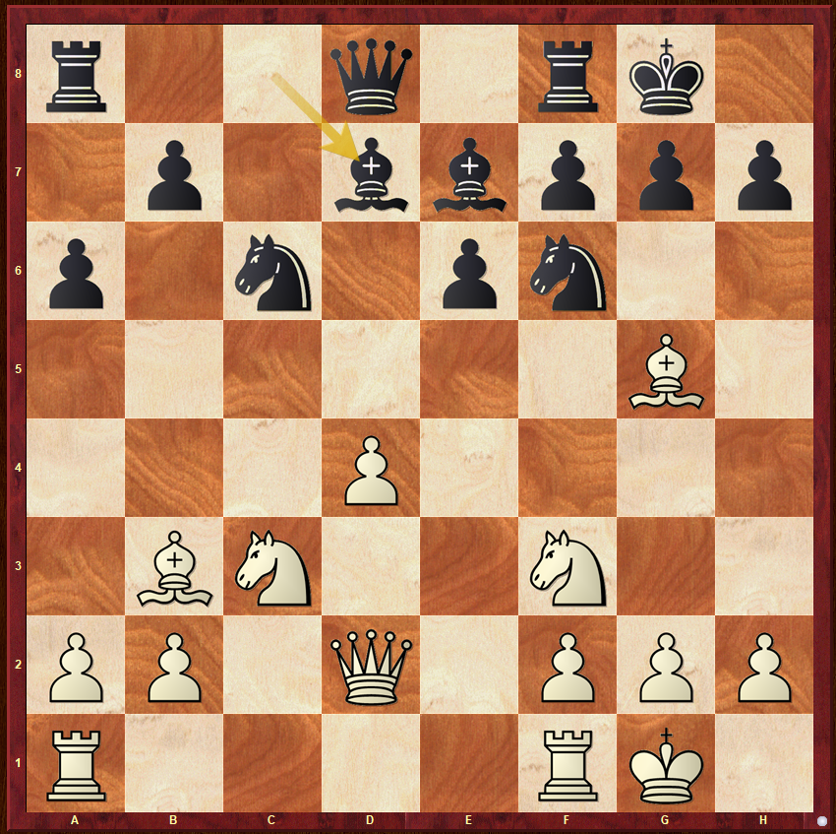

A PAWN STRUCTURE
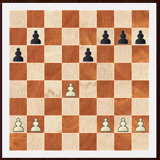

This is a standard pawn structure called an “Isolated “Queen Pawn Structure “or “IQP”
.
The structure is also referred to as the isolani. – It is an extremely important pawn structure. It arises in many opening variations; the Queen's Gambit accepted, Slav, Tarrasch Defence, Sicilian Alapin or French Tarrasch to name a few. This structure is equally common with either color...
Generally speaking, White has better middlegame prospects, while Black has better prospects in an endgame. Therefore, White's main aim will be to build an attack, while Black's hope will be to neutralize such an attack and simplify the position, obtaining a superior endgame.
Delaware Valley Chess Club
Lesson 3

A PLAN
White's plans
1. Create a kingside attack. Most standard plans will include the moves Ne5, Bg5, and the battery Qd3-Bc2. In some cases, a piece sacrifice on the kingside is needed to break through the defense. Rooks are typically placed on e1 and d1 (or c1), and a rook transfer via the third rank is possible.
2. Break in the center with d4-d5, trading pawns and opening lines with an overwhelming initiative (or even sacrificing a pawn with the same purpose).
Black's plans
1. Trade pieces to win an endgame. In particular, exchange White's good bishop (the light-squared bishop).
2. Place a knight on d5. This prevents the central break d4-d5 and controls some key squares. In an endgame, a rook, bishop, or even a king would be strong on this square.

A Model Game

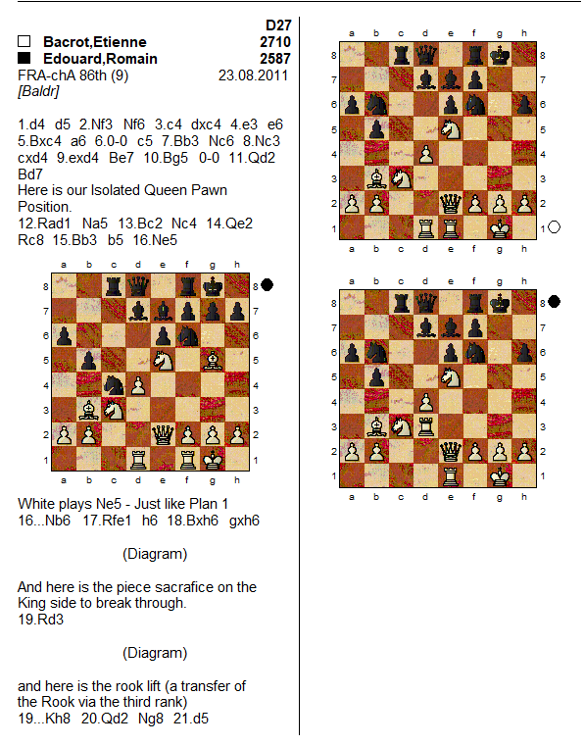

Delaware Valley Chess Club
Lesson 3
HOMEWORK FOR LESSON 3

Anastasia
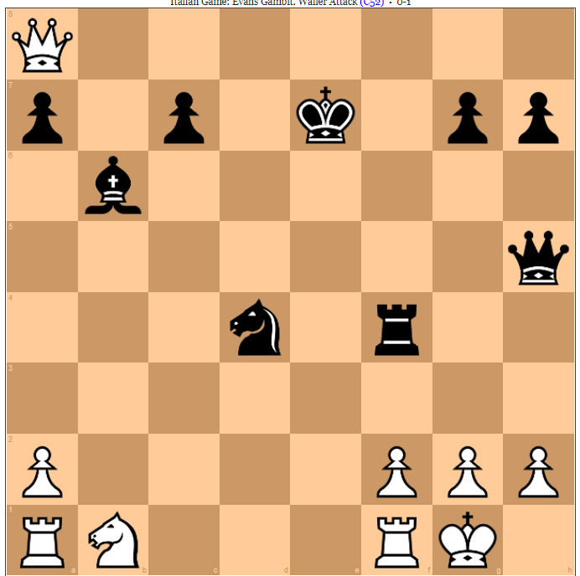
Black to Move

Discovered Attack
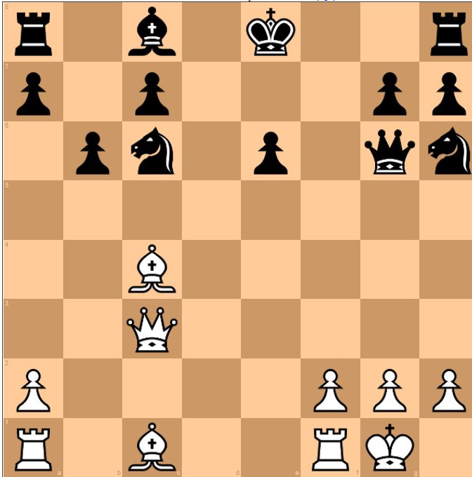
White to Move

Basic Mate 1
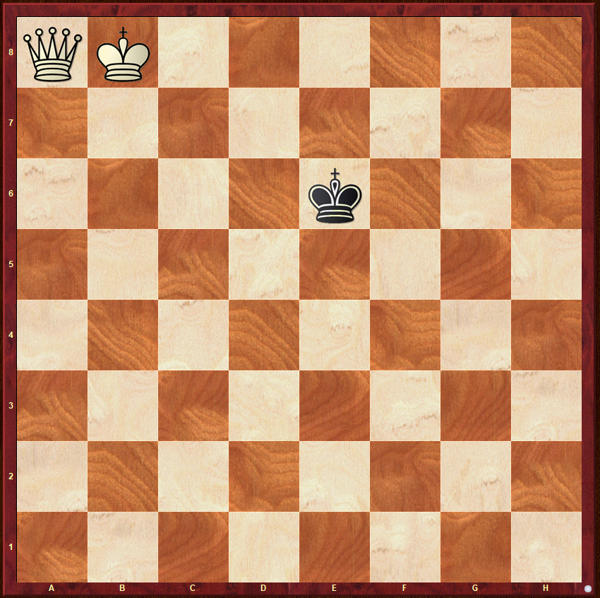
White to Move

