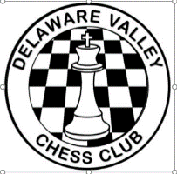 Delaware Valley Chess Club
Lesson 18 Calculation

Simple Calculation (1)
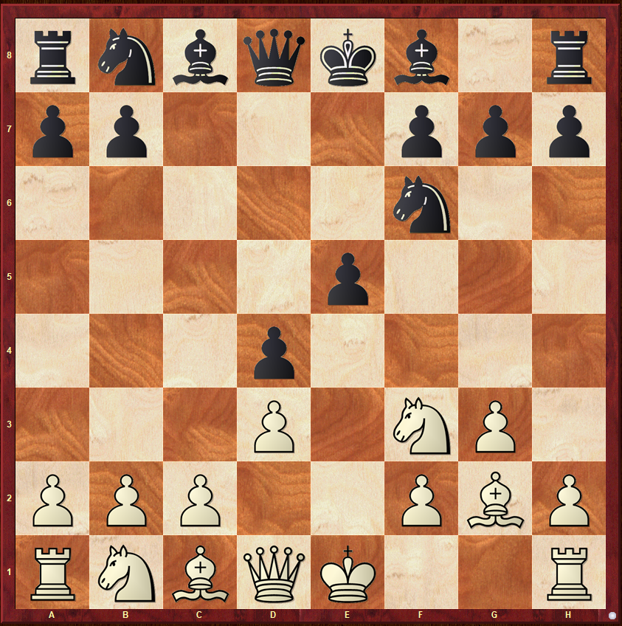
White to Move
Is it safe for White to play Nxe5?

Simple Calculation (2)
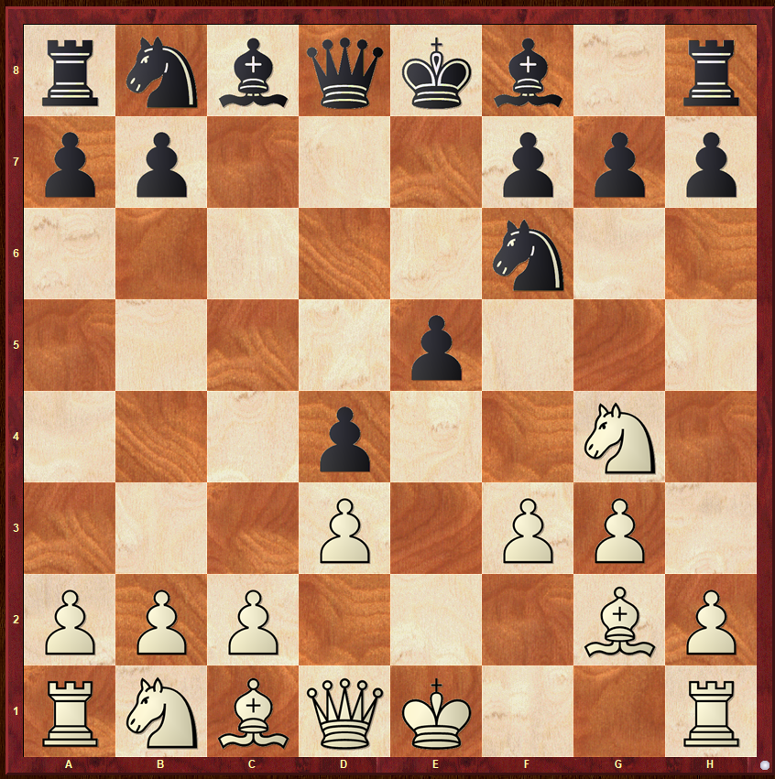
White to Move
Is it safe for White to play Nxe5?

Simple Calculation (3)
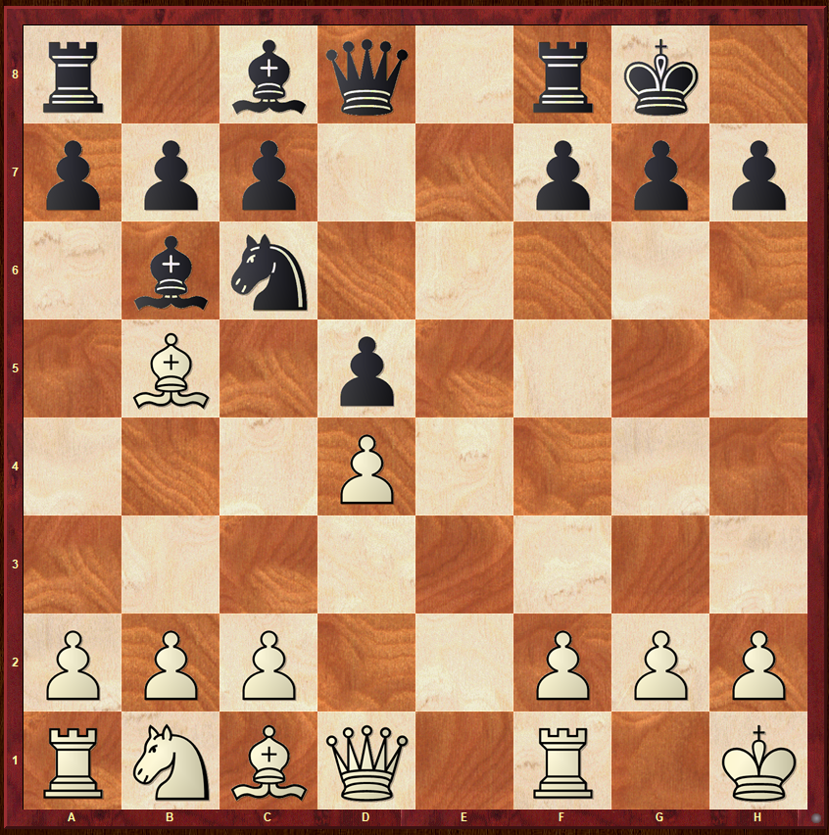
Black to Move

Which of the following moves are safe?
a) 1...Nxd4
b) 1...Bxd4

Delaware Valley Chess Club
Lesson 18

Simple Calculation (4)
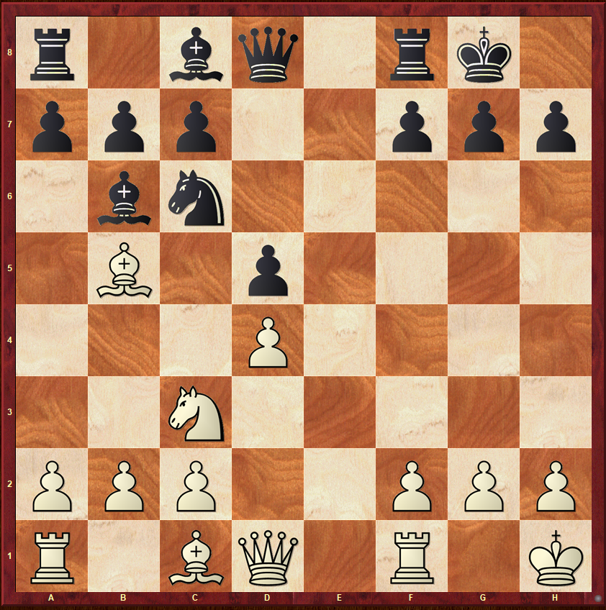
Black to Move
Is it safe for Black to play Bxd4?

Simple Calculation (5)
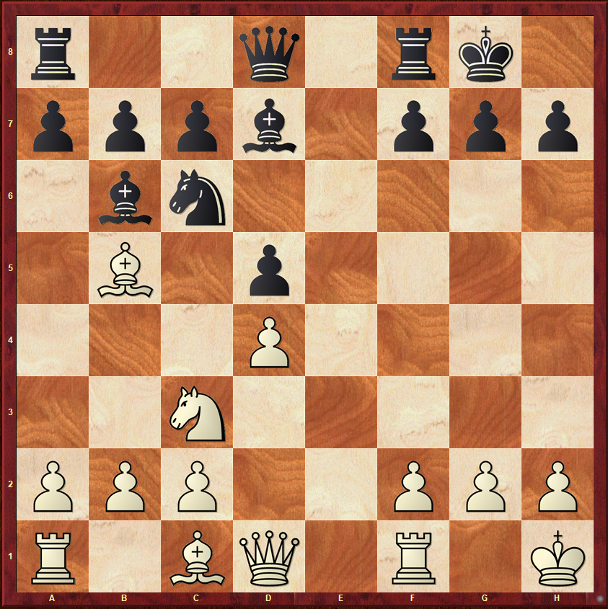
White to Move
Is it safe for Black to play Bxd4?

