Delaware Valley Chess Club
Lesson 14

Missing f7 pawn
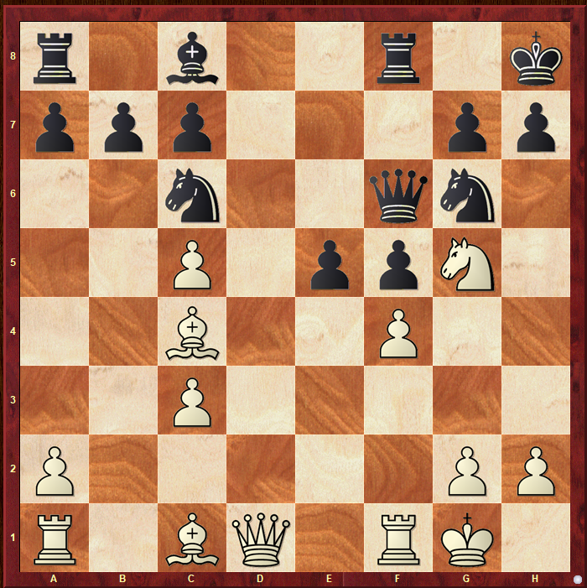
White to Move
The missing f7 pawn is a serious problem especially if there is a Bishop on the a2-g8 diagonal.
Another Fork
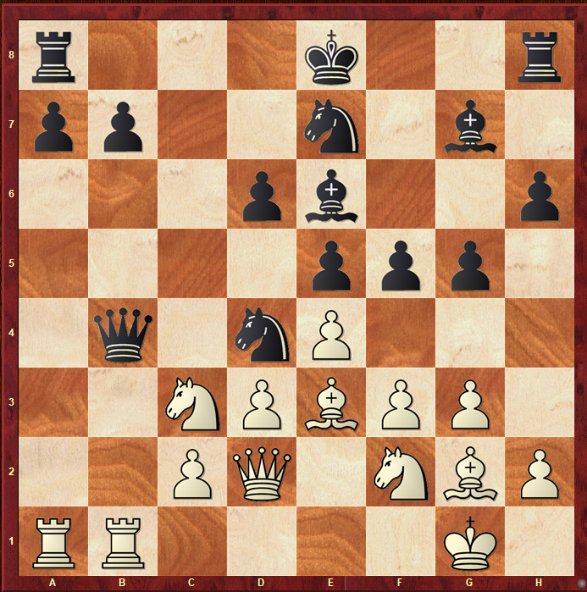
Black to Move
Sometimes you must set up a fork.

Key Squares
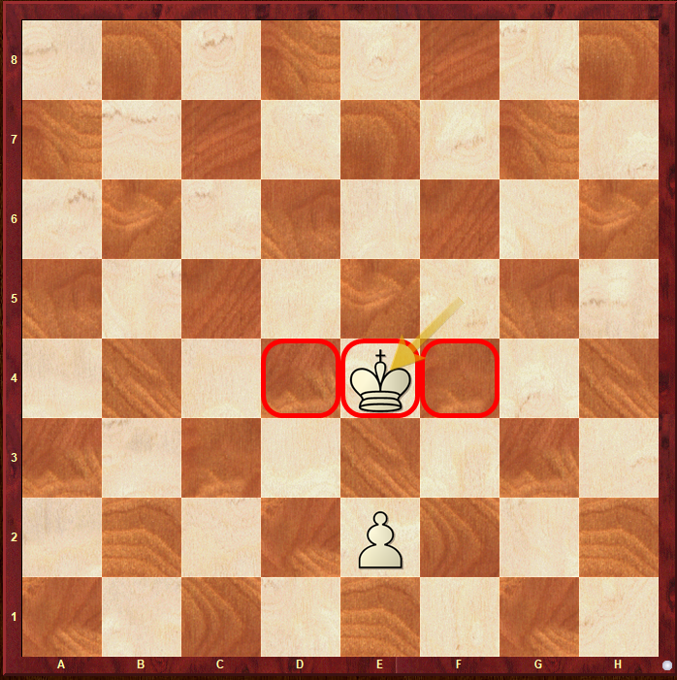
Key Squares follow the Pawn
Knowing the idea of key squares will often provide a target or “building block” position.

Delaware Valley Chess Club
Lesson 14 – Openings: Evans Gambit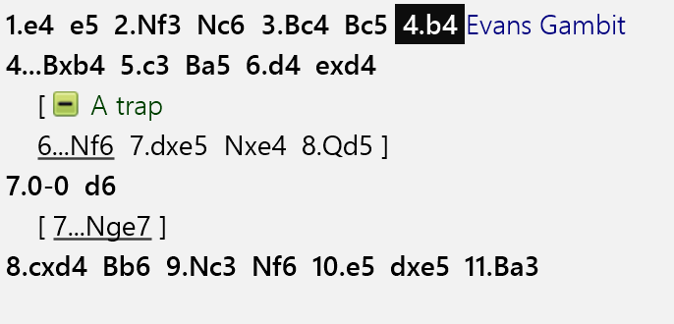

Delaware Valley Chess Club
Lesson 14 – Openings: Evans Gambit

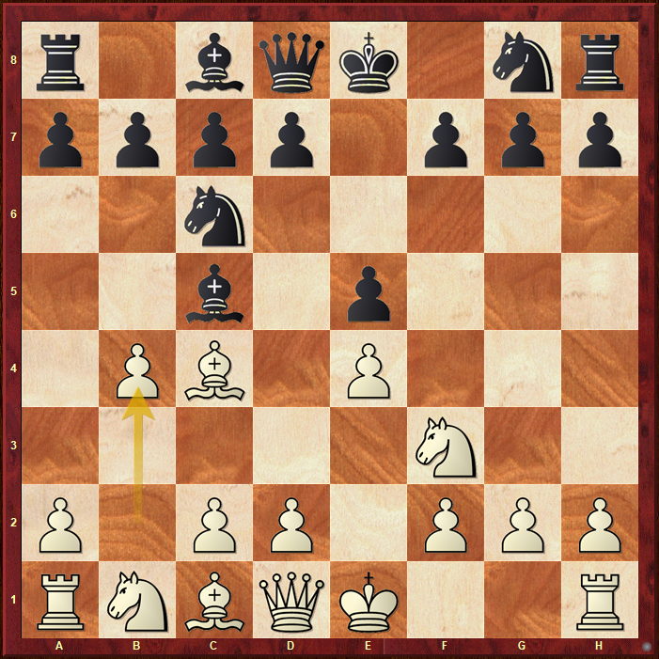
Evans Gambit

