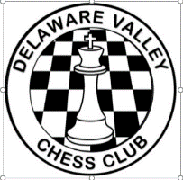 Delaware Valley Chess Club
Lesson 13

Another Anastasia
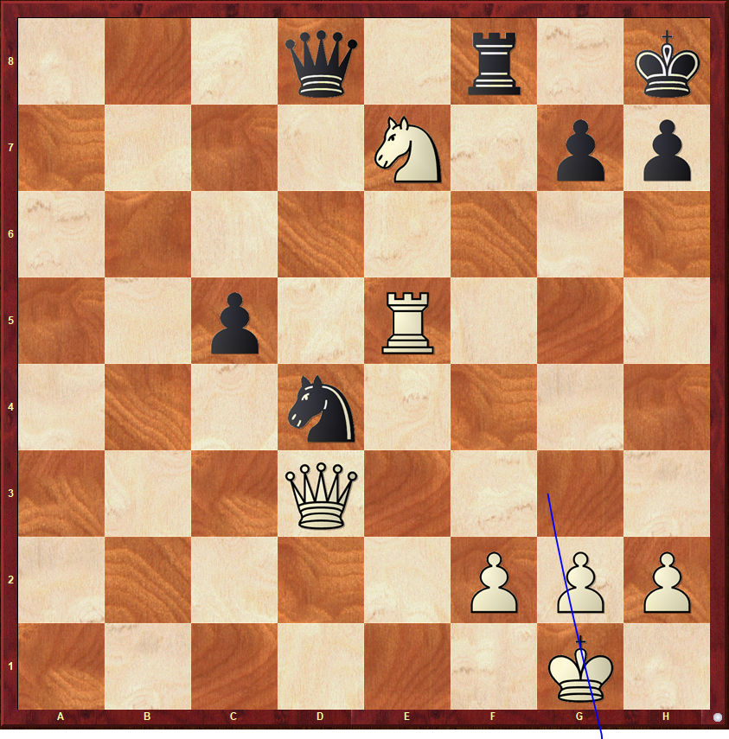
White to Move
For the 1st 2 positions remember from the week 12 lesson. NM Dan Heisman’s guideline to look for checks, captures, and threats.
Another Fork
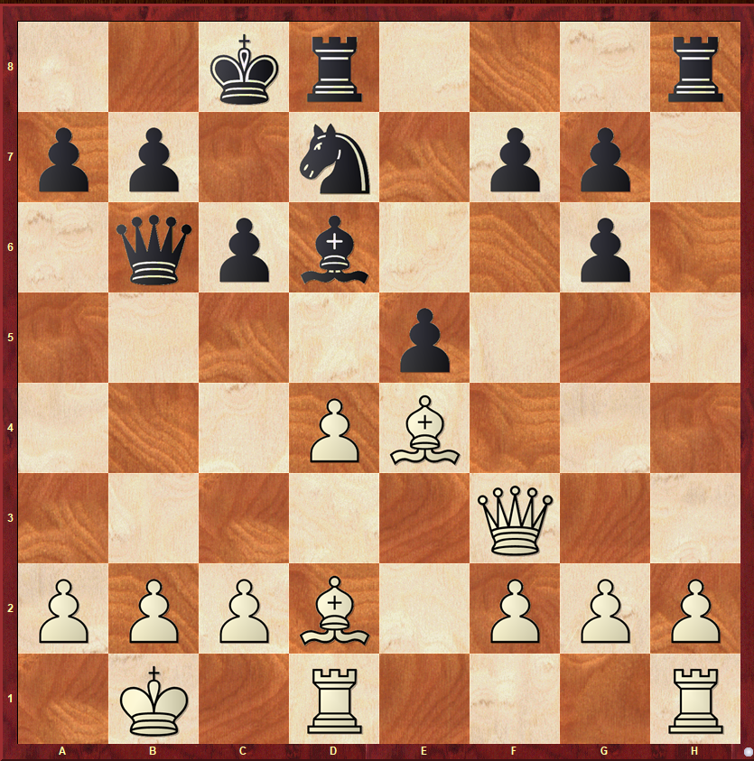
Black to Move

Rule of the Square
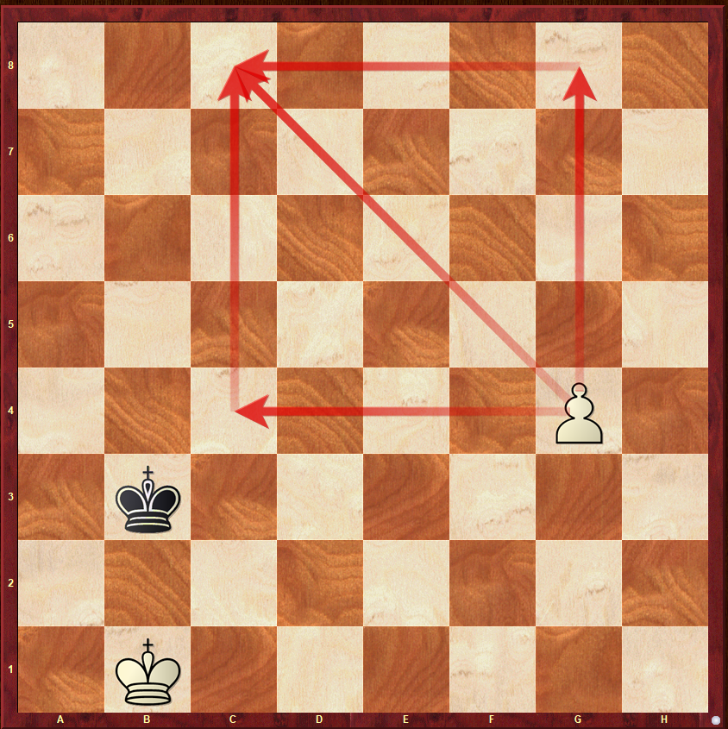
White/Black to Move
Knowing the “Rule of the Square” means it’s easier to answer the question – Can the pawn promote on its own?

Delaware Valley Chess Club
Lesson 13 – Openings: Giuoco Piano
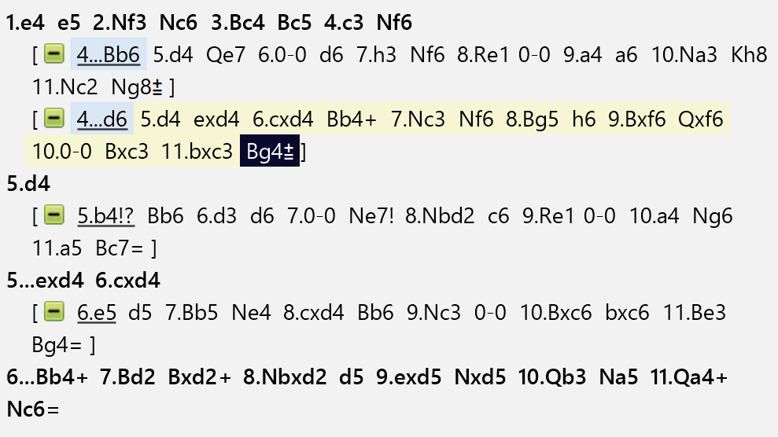

Delaware Valley Chess Club
Lesson 13 Ideas from Reuben Fine
- Open with either the e-pawn or d-pawn
- Whenever possible, make a good developing move that threatens something.
- Develop Knights before Bishops.
- Pick the most suitable square for a piece and develop there once and for all.
- Make one or two moves in the opening, not more.
- Do not bring the queen out early.
- Castle as soon as possible preferably on the King’s side.
- Play to get control of the center.
- Always try to maintain at least one pawn in the center.
- Do not sacrifice without a clear and adequate reason.

